**ITAG File Ingestion Results**

* Once the code execution begins, the ITAG file undergoes processing. The process first validates the header record, followed by the validation of all detail records.  
  

Image 1: Captured during the Execution

* After the ITAG file is fully processed, the ingestion completes successfully. The system provides a summary including the total number of records processed, the count of errors, and the overall runtime of the operation.  
  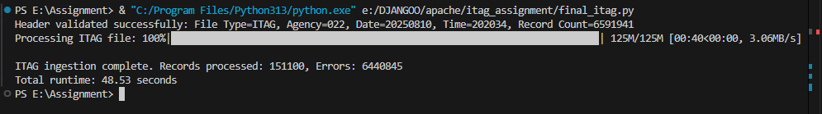

Image 2: Captured after the Execution

* To verify the ingestion, we can query the database to confirm the total number of records inserted. This ensures that the ingested data matches the expected count.  
  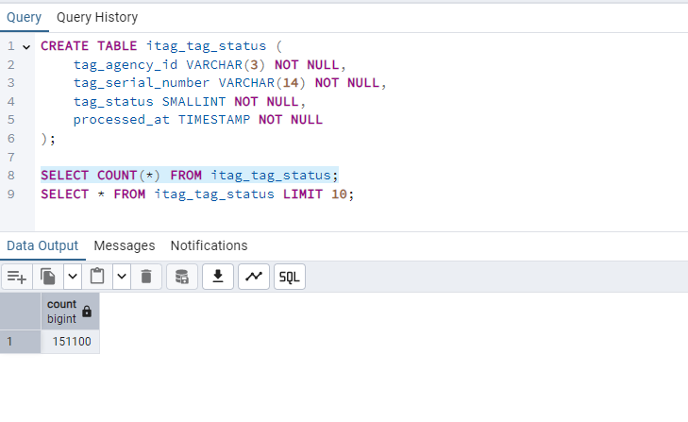

Image 3: Total number of Records inserted into Database

* The ingested records are stored in the designated database table. We can review the table to ensure that the data has been successfully inserted.  
  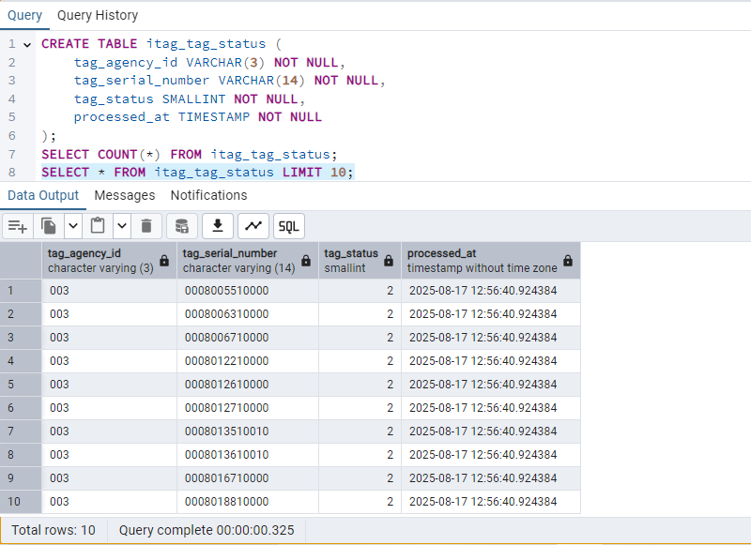

Image 4: Records inserted into Database

* Any errors encountered during the validation and ingestion process are logged (ingestion_error.log). These logs include details such as mismatched counts, invalid records, and other discrepancies.

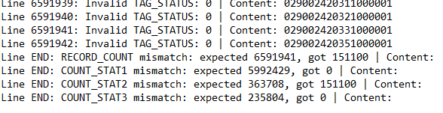

Image 5: Error Records inserted into log